**Module :2- Linux server - Operate running systems**

**20. View Running Processes with ps**

To view running processes, you can use the ps command. Here are some common usages:

Basic Usage:

ps

View All Processes:

ps -e

Detailed View:

ps aux

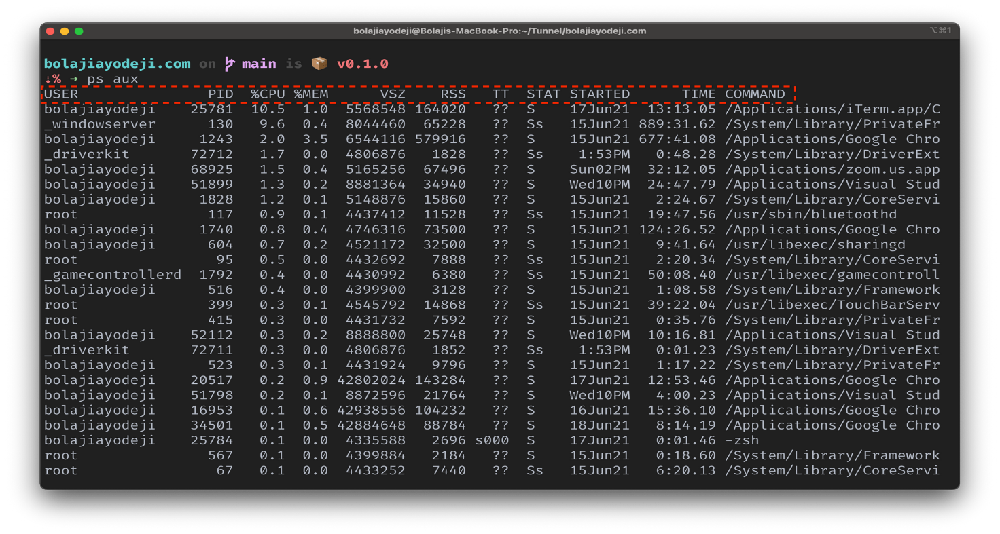

**21. Terminate Processes with kill**

To terminate a process, you need its Process ID (PID). You can find the PID using ps or top, then use kill:

Find PID:

ps aux | grep <process_name>

Terminate Process:

kill <PID>

Force Terminate:

kill -9 <PID>

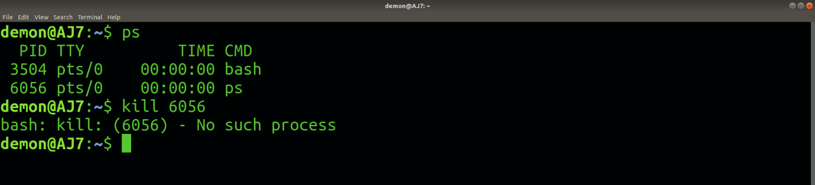

**22. Use top or htop to Monitor System Resources and Processes**

Using top:

top

Using htop (if installed):

htop

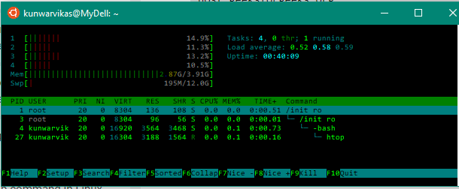

**23. Configure a Computer to Boot to the CLI Using systemd**

Open Terminal and Edit GRUB Configuration:

sudo nano /etc/default/grub

Set Default Target to Multi-User (CLI): Change the line:

GRUB_CMDLINE_LINUX_DEFAULT="quiet splash"

to:

GRUB_CMDLINE_LINUX_DEFAULT="text"

Update GRUB:

sudo update-grub

Set Systemd Default Target:

sudo systemctl set-default multi-user.target

Reboot to Confirm:

sudo reboot